User Manual

How to Secure a File with a Password


Secure a file with password
There are two options for protecting a file with a password:
- Entering a password before the user can download the file.
- Entering a password when the user attempts to open the file on their computer, after it has been downloaded.
It is possible to select one of these methods or both, depending on the type of policy that has been defined. In both cases, the password will be identical and will be set by the sender separately for each recipient.
Password protection prior to downloading the file (Option 1) can be applied in addition to authentication using a one-time password (OTP) sent to the recipient’s email address or mobile phone, or as a replacement for this type of authentication.

Enter a Password Before the User Can Download the File
To share a file that is protected by a password, a policy that includes this type of protection must first be defined.
Please note that this protection option is applied at the email level. This means that if multiple files protected by different protection policies are sent, and at least one of the policies includes this type of protection, the user will be required to enter the password before being able to view all files sent in the same email.

Step 1- Policy Setting
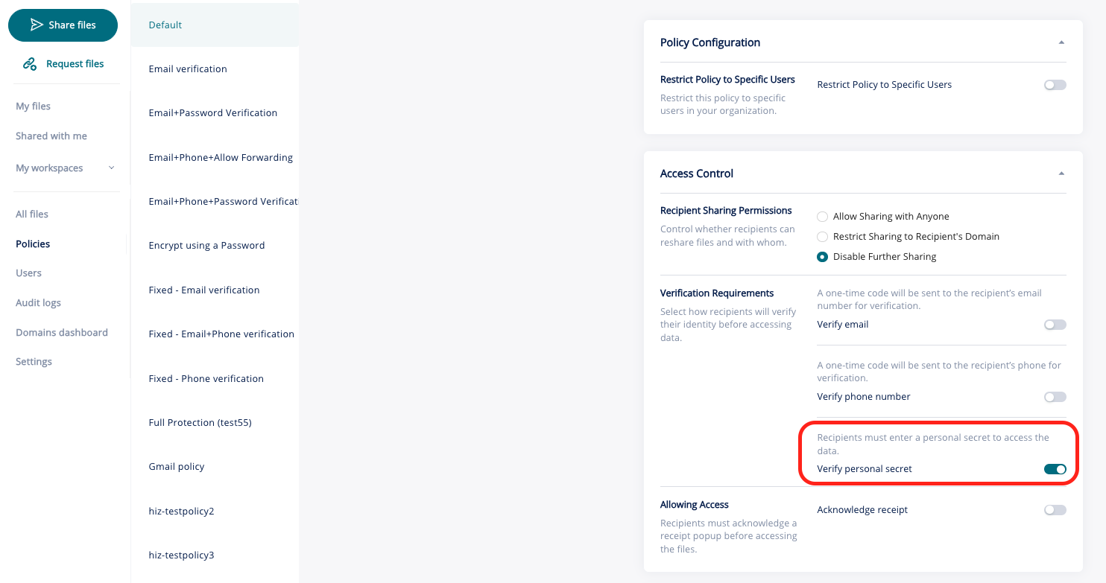
First, navigate to the Policies screen in the system’s Admin interface.
Under Access Control, enable the Verify Personal Secret option.

Step 2 – Sending a password-protected file via Outlook
After defining a policy, the user has to send the file in a protected manner and select the policy that includes password protection.

Once the policy is selected, the sender will enter the password that the recipient will use to open the file. This is done by clicking the pencil icon (marked in red in the screenshot).

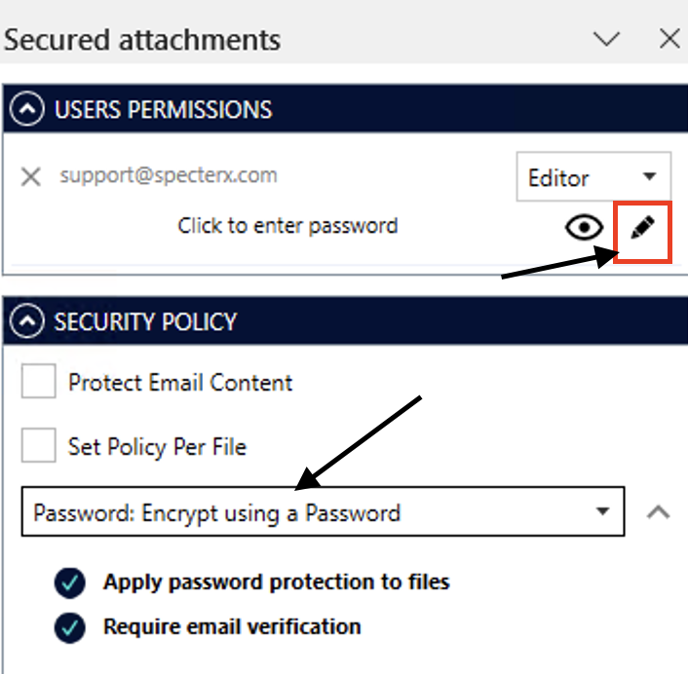

After clicking the pencil icon, a field will appear where you can enter the password. Type the desired password and confirm it by selecting the green checkmark.
Once the password has been entered for the first time, it will be saved for future use. You can change it at any time using the same method (clicking the pencil icon).
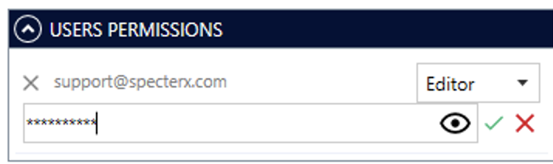

Step 3 – Opening the file by the recipient
When the email reaches the recipient’s inbox, the recipient must click the link. A window will then open prompting the recipient to enter the password.
In the same window, it is possible to add a hint that will help the user identify the password. In this example, the password is the recipient’s ID number.
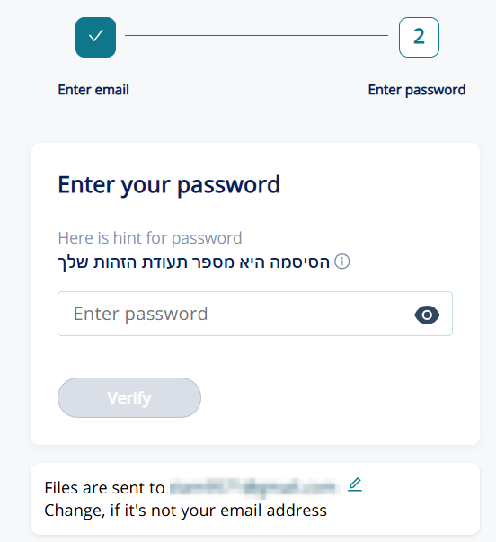

After entering the password, the user will be able to view the file!

Password Entry for Opening the File After Download
Unlike the previous protection type, this protection is applied at the file level, meaning that a password is required in order to open the file itself.
Since this protection applies only at the file-opening stage, the user must also complete an authentication step before being granted access to view or download the files. This authentication can be performed either by entering a password, as described earlier, or by using a one-time password (OTP) that is sent to the recipient’s email address or mobile phone.

Step 1- Policy Setting
First, navigate to the Policies screen in the system’s Admin interface.
Under Data Protection, enable the Encrypt Using a Password option.
Please note that a password can be defined only for the following file types: PDF, DOCX, XLSX, and PPTX.
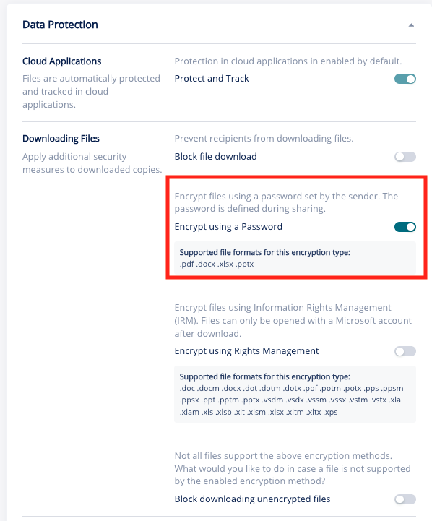

Step 2 – Sending a password-protected file via Outlook
This step is similar to Step 2 described earlier.
To ensure a smooth and user-friendly experience for the recipient, it is recommended to include a note in the email body that indicates which password they will need to enter. For example:
“The attached files contain sensitive information and have been sent to you securely. To view them, you must first authenticate using a one-time code that will be sent to you. After that, to open the files, please enter your ID number.”

Step 3 – Opening the file by the recipient
When the email reaches the recipient’s inbox, the recipient must click the link and complete an authentication process using either a predefined password (as shown earlier) or a one-time password (OTP) sent to the recipient’s email address or mobile phone, בהתאם to the selected protection policy In this example, authentication is performed using a one-time password (OTP):
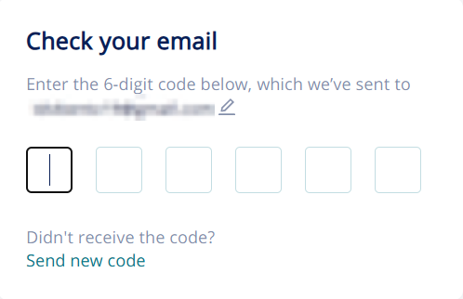
After the user successfully completes the authentication process, they will be able to download the files. When attempting to open the protected file, a window will appear prompting the user to enter the password defined by the sender.
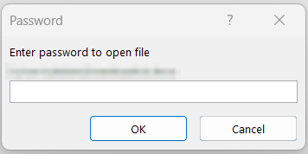
After entering the password, the user will be able to view the file!
If at any point you need assistance, our team is always glad to help.
Find us at: support@specterx.com

